**Mwene waste management initiative**

Kang’ethe brian muchiri.

Pioneer International University.

BIT/0539/2020, information technology.

Dr Wilfred Onyango Odoyo.

Due Date

Background and project mission

According to World Bank estimates, an individual in a developing nation generates 0.45 - 0.50 kilogram of municipal solid garbage on average. Kenya's cities and towns generate around 17,000 tons of trash every day, the most of which is not properly handled or disposed of. The figure is expected to reach 47,064 tons per day within the following 25 years. The Waste Management Project was created by the Mwene waste management initiative to address Kenya's trash problem.

The Project intends to put in place sustainable trash collection, segregation, and treatment systems, as well as a controlled, systematic, and creative approach to reducing waste generation across the country.

# Long term vision

The Project hopes to accomplish four goals in the long term:

Improve Efficiency and Convenience in System usage. Change the waste handling culture through mass scale education programs. Create and Implement Innovative new solutions through research and development use cutting-edge Technology in Everyday systems and operations.

## Stages of involvement

Waste is typically processed in four steps. Mwene waste management initiative's Waste Management Project will be involved in all four stages in the following ways:

**Generation** Analyze and decrease waste sources

**Collection** Identify and improve collection systems

**Segregation** Identify and assess existing processes, then implement more efficient ones.

**Treatment** Identify and assess existing systems before implementing more efficient ones.

### Consequences of waste indiscipline

Waste mismanagement can have a wide range of repercussions in our daily lives. It is responsible for the spread of diseases, the contamination of lakes and water bodies, the loss of biodiversity, and the wasteful use of land and our resources, in addition to generating an unhealthy and unsanitary living environment. It is critical that we organize and manage our country's waste management industry, which is an infrastructure requirement for all other sectors to survive.

**Generation**

Residential garbage accounts for over half of all waste created in Kenya (46.8%). Another 40% originate from commercial and street sources. It is critical to understand the sources of garbage in order to ensure that the collecting process (the following stage) is as efficient as possible. The pie chart below depicts the exact percentages of garbage collected from each source.

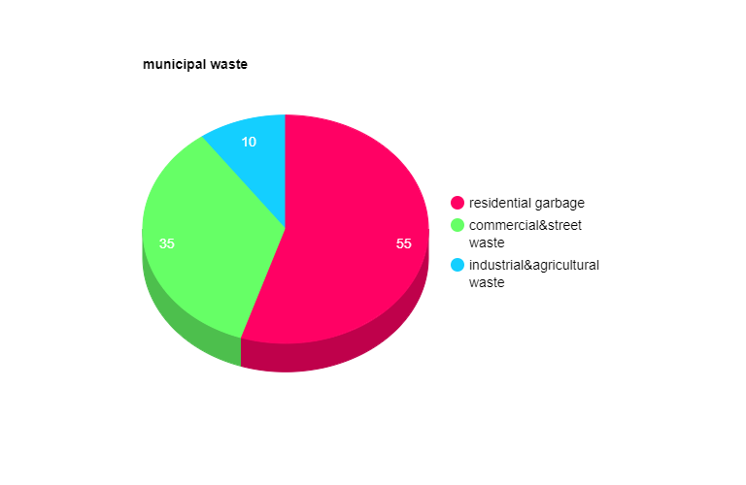

In addition, the pie chart below depicts the makeup of trash in Kenya. More than two-thirds of the waste (70%) is made up of biodegradable foods and vegetables. Garden Waste (11%), Plastic (5%), and Paper Products (4%), all of which are recyclable or biodegradable, are the next highest percentages. This is useful to know so that, once we've identified our sources and established a systematic gathering method, we can also establish an efficient system of segregation at the point of origin.

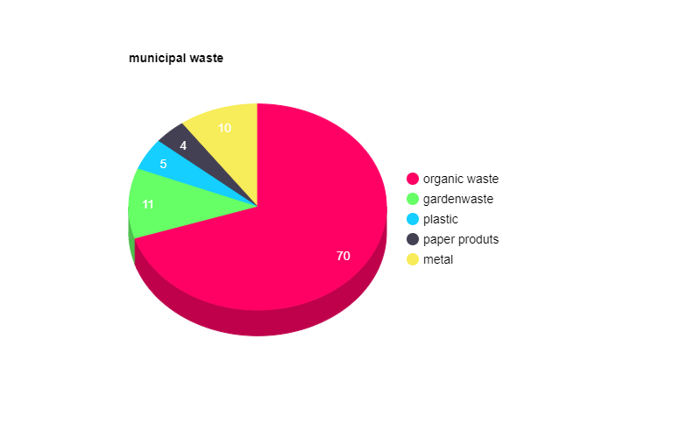

**Collection**

Kenya's waste collecting system is extremely inefficient. Only around 2% of Kiambu County's budget is allocated to trash management, with the only source of revenue coming from fees collected from house to home for rubbish pickup.

**Segregation**

In Kenya, waste is also not segregated at the point of origin, contaminating the biodegradable portion and impeding the appropriate decomposition process. Due to a lack of attention paid to system management, current municipal solid waste has become a mixture of various types of dangerous constituents such as toxic radioactive substances, methane gas, pathogens, industrial effluents, medical, pathological, and harmful chemicals.

**Treatment**

There are four general approaches to waste treatment, which are as follows:

1. Open Dumping Site

2. sanitary Landfills

3.Composting

4. Incineration

5. Plasma Science and Technology

Kenya only uses the first of the five major garbage disposal methods listed above - open dumping grounds. The open dumping ground option merely allows for the dumping of garbage (unsegregated in Kenya), with no treatment.

**Problem under this option**

Many things go wrong in Kenya even with just this one option. The height of the landfills should not be lower than the highest flood level in the area, which is never guaranteed. As a result of the low ground level, anaerobic fermentation replaces aerobic fermentation, prolonging the process of settlement and stability from 2-3 years to decades.

Most of the time, Kenyan authorities do not bother purchasing lands for this purpose, instead relying on private properties for dumping. Under such arrangements, landowners benefit from free land elevation by providing their land for open dumping grounds.

Some of the hazards of Kenya's existing open dumping sites include the lack of engineering design; the dumpsites are not separated from adjacent lands or water bodies, nor do they have retaining walls to prevent leachate drainage. There are also no safety precautions in place. In most cases, landfills do not have bottom liners or top covers.

**Possible treatment solution**

**Composting: the solution for biodegradable waste**

Composting is an excellent waste treatment solution because 85% of our total trash is biodegradable. It is also appropriate because of the high moisture content of our garbage. One of the most significant aspects in waste management is moisture. Municipal solid trash in Kiambu includes up to 65% moisture, compared to 23-32% in Nairobi and 15-35% in Turkana, making it more ideal for composting. Moisture in municipal solid waste aids in the faster and easier decomposition and fermentation processes.

If the garbage is biodegradable, it can be absorbed into the soil without harming the ecosystem if it does not contain harmful elements like plastic. Biodegradable waste can also be used to generate biogas when disposed of in properly planned sanitary landfills.

**Sanitary landfill: solution for non-biodegradable waste**

The second option, the construction of Sanitary Landfills, is the process of dumping garbage after it has been treated to reduce dangers and limit methane gas emissions via the surface. Ground treatment, planning, and engineering work are required for this procedure to be carried out, necessitating an initial financial commitment. Kenya still does not have any hygienic landfills. Earlier in the decade, NEMA attempted to convert a dumping site into a sanitary landfill but was unable to complete the project due to preconditions not being met.

Considering all possibilities and Kenya's socioeconomic setting, the construction of Sanitary Landfills is critical for Kenya to ensure safe waste treatment, the prevention of health dangers, and any harmful impact on the environment. This technology also reduces methane gas emissions and enables the generation of power from garbage, which may attract the attention of the private sector, bringing new opportunities for economic growth.

**Option not suitable for Kenya**

**Incineration** - Due to the high moisture content of our waste, incineration is not an option for us. Wet garbage requires more heat and energy to burn. Residential and commercial trash have moisture values of 50% and 54%, respectively, which are suitable for composting.

**Plasma technology** is simply too sophisticated and expensive for Kenya. It will not be an option for much longer.

**Other possible governmental initiative**

Other government projects that could help enhance the waste management system include:

All enterprises must follow mandatory rules requiring the use of Effluent Treatment Plants (ETPs).

Building new public toilets to prevent the present 60% of Kenyans (who cannot afford any type of sanitary latrine) from contaminating public areas with human waste.

**Organizational goals must be S.M.A.R.T**

**Specific**

**Measurable**

**Achievable**

**Relevant**

**Timely**

The Mwene Waste Management Project Team's goals are briefly described here. All of these objectives will be addressed in greater detail in the Action Projects section of this document utilizing the SMART tool.

**Goal #1: create efficient and sustainable systems**

Kenya's current waste management system is in disarray. The Mwene Waste Management Initiative Project will strive to build an efficient system of operations at every level (collection, segregation, and treatment) that will be self-sustaining in the future.

**Goal #2: reduce generation of waste**

Aside from developing efficient and sustainable waste management systems, the Project will strive to reduce waste generation across the country through large-scale education and awareness campaigns.

**Goal#3: design create solutions**

The Project will engage in constant research and development to incorporate new ideas, creative solutions, and innovative thinking into our already established systems and procedures.

**Goal#4: operate the system using the most advanced technology**

The Project will also strive to include cutting-edge technology in their work and any system designs.

**System focused project**

Given that the three largest sources of garbage in Kenya account for 85.5% of total waste, Action Projects created under the Collection Category will focus primarily on those three sources: **street waste, residential waste, and commercial waste.**

Given that the three major waste composition categories in Kenya account for 90% of the composition, Action Projects under the Segregation Category will focus on those three categories: **Food, vegetable, and garden waste are examples of biodegradable waste. Paper and plastic products.**

**project 1 trash patrol (organizing street waste)**

This project intends to organize the collection of street waste by placing trashcans on all Kenyan public highways. The project will begin in Kiambu County in 2024, followed by the rest of the country in the following years. This is also a collaborative effort with the county government, which will normally charge for emptying the garbage from these receptacles, while Mwene waste management company will fund, operate, and maintain them.

**Design** The trashcans are made of steel and come with a hefty chain and padlock to provide durability, theft protection, and ease of installation. Each trashcan and its attachments cost around $400 per unit.

Timeline: Jan – June 2024 Phase 5-10

(Ruiru) July – Dec 2024 Phase 6 –16

**Budget:** USD 45000

Evaluation factors: number of trashcan setup

1. Trashcans in Good / Excellent Condition (Scores: 0-3)
2. The number of trashcans that are utilized on a regular basis
3. societal qualitative feedback (by are Trashcans in Good / Excellent Condition (Scores: 0-3)
4. The number of trashcans that are utilized on a regular basis
5. Qualitative societal feedback (by area)

Beginning in 2024, the Mwene waste management initiative Project Team will seek to develop a system of segregation for Street Waste at the point of origin (most likely by supplying classified trashcans in addition to our green-colored trashcans).

**project 2 (residential area)**

Project 2 will begin in 2024 and will try to arrange garbage collection and segregation from residential sources in Ruiru.

**Project 3 commercial waste**

Project 3 will begin in 2024 and will try to arrange garbage collection and segregation from commercial sources in Ruiru.

Projects 1, 2, and 3 will be copied throughout the country only if a viable model is established in Ruiru subcounty.

**Treatment projects**

**Project 4 composting**

Given the benefits of composting in terms of moisture content, atmospheric compatibility, and waste biodegradability for Kenya, this Action Project will be a primary emphasis of our Mwene Waste Management Project in the coming years. The project's goal is to put up composting units across the country and use composting as a significant method of removing 85% of our total waste. Beginning in 2024, this Project will be designed in greater detail.

**Project 5 recycling**

This project, which will begin in 2024, will aim to establish recycling plant units for paper and plastic goods in various parts of Kenya.

**Other options**

In the long run, we hope to develop a sanitary landfill in Kenya in collaboration with the Kenyan government and international institutions such as JICA and the UN.

Only after establishing a successful model in Ruiru will treatment projects be copied throughout the country.

**Awareness based programs**

Awareness raising and public education are critical components of our daily work. In Kenya, environmental education and waste management discipline are severely inadequate. The Mwene Waste Management Project Team will create Awareness-based Programs to encourage environmentally friendly habits throughout the country.

**Project 6 schools**

This Project will provide research-based creative programs for children (of various ages) that will be integrated into school curricula across the country. The Project will try to instill environmentally responsible habits in youngsters at a young age. There will be four programs established, each for a distinct age range, and all of them will include the following components: creativity, thought leadership, and the learning of best practices.

**timeline:** January to March Design Programs for Children Ages 3 to 6 (2024)

April through June Create programs for children aged 7 to 10.

July to September Design Programs for Children Ages 11 to 14

Design programs for ages 15 to 18 are available from October to December.

**Project implementation timeline in Ruiru sub county**

(Total Number of Schools: 105)

(2024) January – March Program launch in 26 schools

April – June Program launch in 26 schools

July – September Program launch in 26 schools

October – December Program launch in 27 schools

Factors for evaluation include participation rate, behavioral change, initiative taking, and creative development.

After establishing a successful model in Ruiru subcounty, the education programs will be expanded throughout the country.